

COLLEGE of INFORMATICS and ELECTRONICS

Department of Computer Science
and Information Systems

End-of-Semester Assessment Paper

Academic Year: | 2004/05 | Semester: | Summer
Module Title: | Computer Networks | Module Code: | CS4225
Duration of Exam: | 2½ Hours | Percent of Total Marks: | 100
Lecturer(s): | Dr Séamus O’Shea | Paper marked out of : | 100

Instructions to Candidates:

- Answer any three questions.

1.
- Differentiate between connection-oriented communication on the one hand and connection-less communication on the other hand. Indicate what type of network conditions would suggest the use of each mode of communication. (11 marks)
- Draw a diagram to show two periodic signals which are (i) 90º (ii)45º and (iii) 180º out of phase with respect to each other. (Assume same frequency and amplitude) (10 marks)
- The following diagram shows a modulated analog signal. Describe the type of modulation in use in this example. How many distinct phase changes occur? How many separate line states can be distinguished? (12 marks)

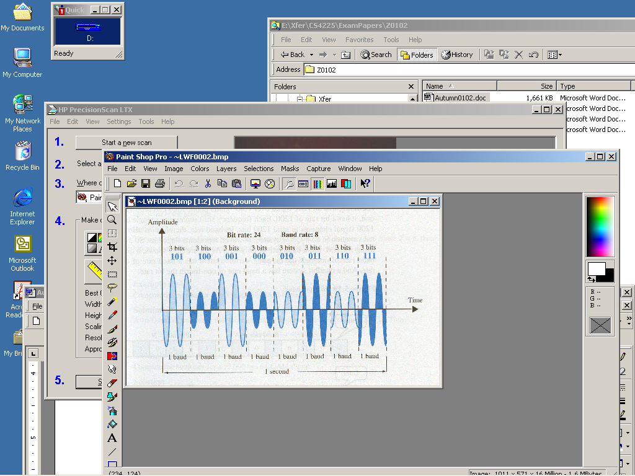

2.
- Define the decibel unit of signal intensity. If signal S₁ is 30 db greater than signal S₂, what is the ratio (S₁/S₂) in absolute terms? (10 marks)
- State some desirable properties of a line code, and explain briefly why each property is desirable. Draw a diagram to show the structure of the AMI code and comment on it’s properties (10 marks)
- Suppose a digital video camera (i.e camcorder) generates 30 colour images per second, whose resolution is 1024 x 768 pixels. A pixel’s colour is encoded using 5 bits. The images are transmitted over a link whose bandwidth is 4.5Mhz and whose signal-to-noise ratio is 30dB.In the absence of any compression, will the link be able to carry the transmission? (13 marks)
3.
- Show, via examples, how classfull IP address allocation is wasteful, and how CIDR reduces such waste. An IP address of 200.13.5.29 has an associated mask of 255.255.255.0. How many bits does the hostid space contain? (8 marks)
- How many addresses does the 200.11.0.0/19 block contain? Which of the address blocks 200.11.0.0/19 and 200.11.0.0/21 is the smaller? How many of the smaller blocks are contained in the larger block? (6 marks)
- Suppose your PC has an IP address of 192.168.13.5/24. It is configured with a Default Gateway which has an IP address of 192.168.12.5/24. Will the PC be able to communicate with remote networks? Explain briefly. (8 marks)
- A network interface on a user’s PC is allocated the IP address 192.168.6.51/27. The user’s Default Gateway has the configuration 192.168.6.83/27. The PC user pings the interface 192.168.8.11. Explain the results. (12 marks)

4.
- Draw a diagram to show the necessary exchange of messages to set up a TCP client connection to a server. (5 marks)
- Give examples of connection attributes that can be negotiated at set up time. (5 marks)
- On transmission, is the IP datagram encapsulated in the TCP segment, or is the TCP segment encapsulated in the IP datagram? (5 marks)
- What is the TCP response if a received segment fails the checksum? How does TCP recognise received segments which are not in sequence? (6 marks)
- How does TCP differentiate between client connections which are multiplexed onto the same server port? (6 marks)
- How is flow control achieved between two communicating TCP entities? (6 marks)

5.
- Briefly describe the CSMA/CD access protocol. Draw a diagram to show the structure of an Ethernet frame. Why is it necessary sometimes to use a padded frame? Are Ethernet frames of fixed or variable size? (10 marks)
- Contrast the internetworking functions which are performed by Bridges, switches, and Routers. If an Ethernet network consists of many separate segments interconnected by a bridge, does the bridge have to contend on the same basis as user stations in its task of forwarding frames from one segment to another? If a bridge cannot associate a MAC destination address with an outgoing port, how does it forward the frame? (10 marks)
- Discuss the forwarding problems associated with multiple paths between network segments, and discuss briefly how the spanning tree algorithm is applied to the solution of those problems. (13 marks)

